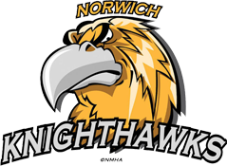 Rowan’s Law Acknowledgement Form

Participant name (first and last):

Participant Type (check one):

_____ Coach/trainer/bench staff _____Player _____Parent

Participant Birthdate:

Team Level:

Parent/Guardian Name:

Email:

The above named participant and parent/guardian (if applicable) has/have reviewed the OHF Concussion Code of Conduct and the appropriate Concussion Awareness Resources and commit to operating within the parameter of the OHF Concussion Code of Conduct under the role which the Participant and Parent/Guardian (if applicable) has/have registered with the OHF.

Signature:________________________________________________________________

Rowan’s Law Acknowledgement Form

Participant name (first and last):

Participant Type (check one):

____ Coach/trainer/bench staff ____ Player ____Parent

Participant Birthdate:

Team Level:

Parent/Guardian Name:

Email:

The above named participant and parent/guardian (if applicable) has/have reviewed the OHF Concussion Code of Conduct and the appropriate Concussion Awareness Resources and commit to operating within the parameter of the OHF Concussion Code of Conduct under the role which the Participant and Parent/Guardian (if applicable) has/have registered with the OHF.

Signature:________________________________________________________________

