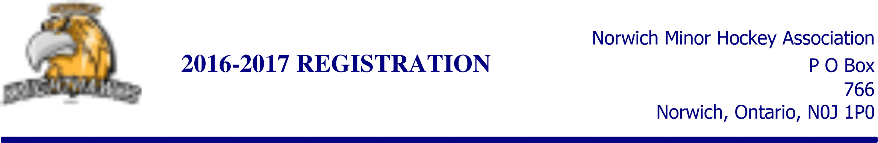
LAST NAME | FIRST NAME | DOB | GOALIE* if applies | Rep tryout $40 | FEES
 |  |  | 50/50 Tickets |  | + $50
 |  |  |  | TOTAL OWING of all players incl 50/50
Players Address: __________________________________________________________
Home Phone#: __________________________________________________________

Primary Email address: ____________________________________________________

Mother’s Name/cell#: _______________________ _______Father’s Name/cell#: ________________________________

COACHING: If interested in coaching, please check here:

Respect in Sport Parent Program: A parent or guardian has completed the RIS parent program for your players to be rostered to a team. Information is available if you have not completed the program. Please initial to acknowledge you have read and understand the above: ______

By signing this form you agree you to abide by NMHA Player/Spectator Code of Conduct (available on website) and as members of the Norwich Minor Hockey Association will abide by both the NMHA’s as well as OMHA’s Code of Conduct. Signature: _______________________________________________
Payment method: CASH: |  | CHEQUE: |  | 2017-2018 Registration FEES
 |  |  |  | Early Bird | $550 *before June 30th.
REG/POST Dated | AMOUNT | CHQ# |  | Beginner/Tyke/  First time to Hockey | $395
#1)  To qualify for early bird, first cheque MUST be paid by June 30th- min. $185/player | $ |  |  | Novice to Midget | $615 *After June 30th
#2) | $ |  |  | REP TRYOUT FEE | $40
#3) | $ |  |  | VOLUNTEER FEE | $300
TOTAL: | $ |  |  | Family Discount  First two players= regular price  Each additional player is ½ price  *Applied to lowest registration fees
VOLUNTEER FEE:  *post dated to Jan 1st | $300

