PLAYING RULES
1) Games are 27 Minutes long run time with a 3 min warm up. Game sheets must be filled in prior to game start time.
2) General rules of the CHA rulebook will be used with the following amendments:
3) Penalty shots accrued will be taken at the end of each game in order of players listed on the game sheet. If a team has accumulated 5 or more penalties, only the difference in the number of shots will be taken by the team with the least penalties.
4) NO BODY CONTACT is allowed in any division and slap shots are allowed.
5) A face-off will start the game. At all other times when the puck leaves the playing surface, it shall be restarted immediately with possession given to the team that did not cause it to go out of play & at a spot near the stoppage but not in the offensive zone.
6) There will be no icings called, and the centre line is not used for off-side calls.
7) CSA approved helmets, facemasks and neck guards MUST be worn by all participants in all divisions.
8) After a goal is scored; when the goalie freezes the puck; or an offside at the blue line, the referee will blow his whistle indicating that the offensive players must clear the zone & tag up at the blue line simultaneously. They now become defensive players and can re-enter the zone to pursue the puck. They CANNOT intentionally play the puck while it is still inside the zone & they have not yet cleared to tag-up, or they will be assessed a “delay of game” penalty.
9) For any penalty, time will not be served in the penalty box. Instead, once the referee calls the penalty as usual (delayed whistle) when the offending team gains possession of the puck, the referee notifies the scorekeeper of the infraction which is recorded. The puck is then turned over to the non-offending team in the neutral or defensive zone, nearest to where play was stopped. Penalties are recorded and at the end of the game, shots are taken according to the order of the players listed on that game sheet. Shots will be taken simultaneously (unless there is only one referee).
10. If at any time the opposing team has a 5-goal lead, the team that is losing may add a 4th skater on the ice. If that 5-goal lead is no longer, you must revert to 3 on 3 play.
Conditions:
Our league stresses SPORTSMANSHIP & FUN. Any player assessed a roughing penalty will be expelled from the game. Any player assessed a major or match penalty, a “checking from behind” penalty, or a misconduct for abuse of officials, will be expelled from the league with no refund, pending review by NMHA 3 on 3 Committee.
In addition to the above, any player assessed a fighting penalty will be expelled from the league with no refund. A player who receives consecutive roughing penalties will have their conduct reviewed and may face expulsion from the league. NMHA reserves the right to expel any player it feels violates the conditions stated above. Note: No carded junior players accepted.

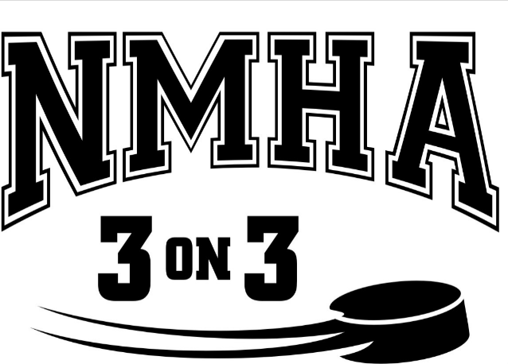

3 on 3 Summer
Hockey League 2021
August 10th- September 2, 2021
Nor-Del Arena
Norwich

NMHA Summer 3 on 3 Hockey League.
Divisions Birth Year
Novice 2014-2013
Atom 2012-2011
Peewee 2010-2009
Bantam 2008-2007
Midget 2006-2004

Games will be Tuesday & Thursday evenings starting at 6pm and a few Sundays. Teams may play on two nights some weeks.
We reserve the right to amend the teams and schedule at any time to allow for balancing of the divisions and schedule.
Number of players per team and number of teams will be based on registration. NMHA reserves the right to combine divisions based on registration.

A waiver must be signed prior to play.

Everything is subject to change depending on Covid-19 protocols.

What does each participant get?
10 games over 4 weeks
A jersey to keep.
This style of hockey should provide each player with more opportunities to handle, pass, and shoot the puck than in regular 5 or 4 aside hockey. Goaltenders can get much more action than usual, due to the opportunities created by so much open ice.
Cost: $210 per player
Mail or email registration form to “Norwich Minor Hockey” to:
NMHA 3 on 3 P O Box 467 Norwich, Ont N0J 1P0
Email: aanobbs@hotmail.com
Registration deadline is July 16th so we can plan the season.
Payment to be collected upon arrival of first game.
A $25 fee will be charged to any NSF cheque.
www.norwichminorhockey.ca

REGISTRATION FORM
Birth year__________________
LAST SEASON: Minor Hockey
Association: _________________
Category: AAA, AA, A, B, C, D
circle one
Player ( ) Goalie ( ) House ( ) A/E -Select ( ) Rep ( )
GIRLS: ( )
Rep ( ) House League ( )
Name_________________
Telephone # _______________
Address___________________
_________________________
City______________________
Postal Code ______________
Email:
_________________________
( ) Parents: Please check if willing to coach a team or assist on the bench. Volunteers are needed at ALL levels.
SPECIAL REQUESTS: __________________________________________________
Special requests are NOT guaranteed.
IMPORTANT!!: Check appropriate level played last season. This allows us to evenly place players. NMHA will move players as it deems necessary in order to achieve even teams.

