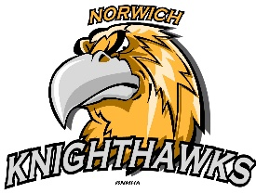
Norwich Minor Hockey Association

P O Box 467 Norwich, Ontario, N0J 1P0
____________________________________________________________________________________________________

Team Information

Organization: (Ex. Norwich Minor Hockey Association)

Team Name: (Ex. Norwich Knighthawks)

Division: (Ex. U9 LL)

Team Colours

Home:

Away:

Contact Information

Name:

Address:

City:

Postal Code:

Contact Email/Phone: email: _____________________________ Cell Phone: _______________

Cost for Tournament is $800.00 per team
Please make cheque payable to: Norwich Minor Hockey Association or
E-Transfers Available to treasurer@norwichminorhockey.ca

Mail to:
Erin Davis
PO Box 15
Otterville, ON
N0J 1R0

Or email Erinbickell600@hotmail.com

